CSA1503-Cloud computing and big data analytics
Experiment 17
Title: Change Hardware Compatibility of a Virtual Machine and Execute UNIX Commands
Aim
To change the hardware compatibility of an existing Virtual Machine and execute basic UNIX commands.
Procedure
- Shut down the Virtual Machine.
- Open VMware Workstation.
- Right-click the VM and select Manage → Change Hardware Compatibility.
- Select the required VMware Workstation compatibility version.
- Click Next and Finish.
- Power on the Virtual Machine.
- Open the Linux terminal.
- Execute the following UNIX commands:
- Verify that the commands execute successfully.
Output
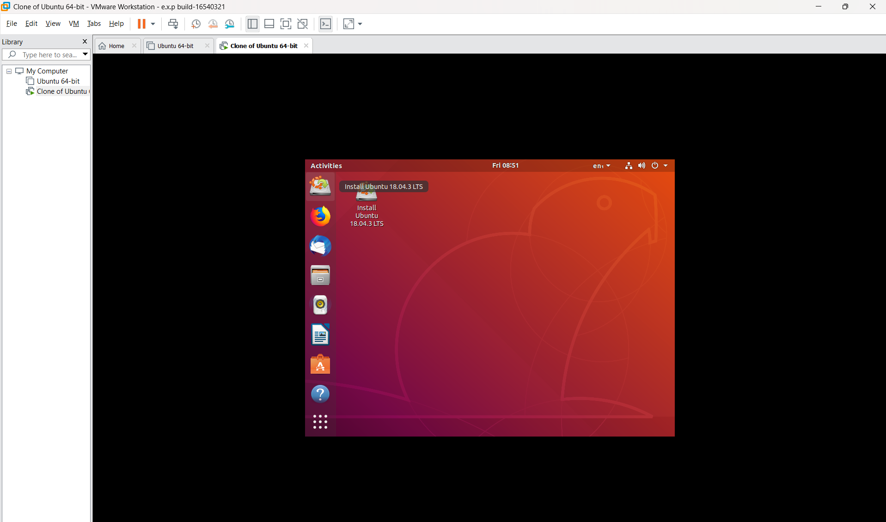
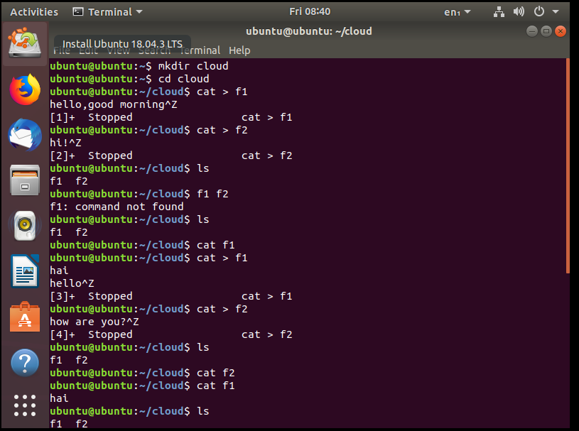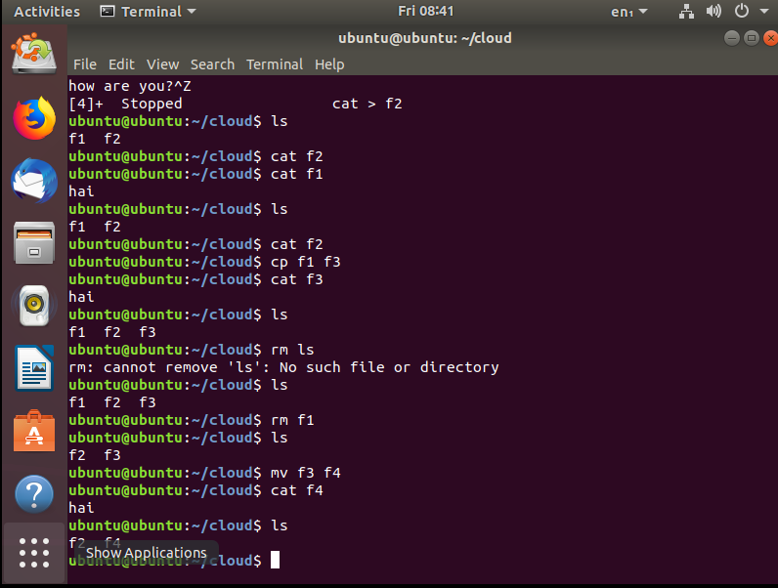Result
The hardware compatibility of the Virtual Machine was successfully updated, and the Linux Virtual Machine executed basic UNIX commands without errors.

